Dr. J- Artificial Intelligence Breast Cancer Screening Robot
Frequently Asked Questions

iCare365 Technologies, Inc.

Contents
Part I. Training 1
I. Is Dr. J easy to use? How long does it take to master it? 1
2. What are the requirements for operators? Is training provided? What does it include? 1

Part II. Important Operational Guidelines 2
1. Are there any specific qualifications required to operate Dr. J? Is an ultrasound physician certification necessary? 2
2. What are the key operational precautions when using Dr. J? 2
3. Why is it necessary for operators to perform the scan at least twice? 4
4. Can Dr. J operate offline? 4
5. What are the network requirements for Dr. J? 4
6. How long does a Dr. J screening take? 4
7. How does Dr. J ensure quality control (prevent missed scans and locate lesions)? 5
8. Does poor ultrasound image quality increase the risk of misdiagnosis? 5
9. How long does it take to receive screening results? 5
10. Who is recommended to undergo screening with Dr. J? 6
11. Can women undergo screening during menstruation, pregnancy preparation, pregnancy, breastfeeding, after breast augmentation, or after mastectomy? 6
12. If the probe is scanned vertically and the operator's hand blocks the camera, preventing visibility of the scan point, will it affect the results? 6
13. Why does the probe heat up during operation? 6
14. Why do the thumbnail image in the tracking display and the large image on the right look different? 7
15. Why is the ultrasound image collected by the probe not clear? 7
16. Does the probe distinguish between left and right? 7
17. If the Dr. J system generates two images that appear to show the same nodule, should I classify it as one lesion or two? 8
18. I have completed the screening, but why can’t I see the result image on the right side of the screen? 8
19. Why is the AI-marked lesion area larger than the manually marked area by an ultrasound doctor? 8
20. The lesion position marked on the clock diagram is similar, but the system generates multiple images. What do these different images represent? Are they different cross-sections of the same lesion? 8
21. How should false-positive images caused by improper operation be handled? 9
22. Can Dr. J detect lesions smaller than 3mm? 9
23. Why does the message "Device is in use, please confirm" appear when opening the camera, and how can I resolve it? 9
24. Will a red network warning affect normal usage? 10
25. Why can't I find previous patient information in the patient list? 10
26. Why is there no image for the screened individual? 10
27. Can Dr. J detect nodules smaller than 3mm? 10
28. Can Dr. J scan underarm lumps? 11
29. Why can’t I see the “Trajectory Tracking Map”? 11
30. Why does the lesion type only show "abnormality" instead of specific classifications? 11
31. Why is there no response when clicking "New" to add the next subject after completing a scan? 12
32. What should I do if the captured lesion images are blurry? 12
33. How should the ultrasound probe be maintained and cleaned? 13
Additional Guidelines 13

Part I. Training

I. Is Dr. J easy to use? How long does it take to master it?
A complete beginner with no prior ultrasound experience typically requires 2-3 days of training to pass the assessment. While the system is designed for ease of use, hands-on practice is mandatory after training. Operators must strictly follow Dr. J’s AI-guided scanning procedures to ensure accurate image acquisition. Those who fail to comply with the required scanning techniques will not be allowed to operate the device.

For ultrasound doctors or technicians, their conventional probe-handling techniques may differ from Dr. J’s AI-driven scanning method. It is essential to emphasize the differences and ensure they do not simply replicate traditional ultrasound probe movements when using the device.

2. What are the requirements for operators? Is training provided? What does it include?
Our product has minimal medical background requirements for operators. It can be used by ultrasound doctors or technicians, but in cases where ultrasound professionals are unavailable, trained nurses or other medical staff can also operate the device.

We provide comprehensive training, which includes:
- Breast cancer-related medical knowledge
- Product introduction
- Screening workflow
- Hands-on operation training

Part II. Important Operational Guidelines
This section outlines critical protocols to ensure safe and effective use of Dr. J during breast cancer screening.

1. Are there any specific qualifications required to operate Dr. J? Is an ultrasound physician certification necessary?
Dr. J does not require operators to hold an ultrasound physician certification. Nurses, medical staff, or any personnel with basic medical knowledge can operate the device after completing a short training program. However, all trainees must pass a strict assessment before being officially certified to operate Dr. J.

2. What are the key operational precautions when using Dr. J?

To ensure high screening accuracy, the ultrasound scanning process must follow strict standardized procedures. The following key points must be observed during the scan:

- Apply firm pressure during scanning, ensuring the probe is pressed against the skin so that the skin fully wraps around the probe surface. There must be no gaps between the probe and the skin.
- The probe must be perpendicular to the skin, and the scanning speed should be slow and steady. Use sufficient coupling gel to avoid air gaps between the probe and the skin.
- A complete scan must include:
- Two full scans in a radial pattern
- Two full horizontal scans
- Two full vertical scans
- Two focused scans around the nipple area
This ensures full breast coverage and minimizes the risk of missing any abnormalities.
- The entire breast must be scanned thoroughly, with at least two complete passes over the entire area.
- Adjust brightness, gain, and focus settings to ensure the ultrasound images are clear and high-quality.
- When the ultrasound is not in use, freeze the probe to protect it.

Precautions

1. In the camera video feed on the screen, the patient's head must be positioned at the top.
2. For devices without an automatic camera tracking function (such as the Lite version of Dr. J), the operator must manually mark the lesion location by clicking on the clock diagram in the system using a mouse.
3. Double-check that the patient’s ID number has been successfully saved.
4. Ensure that the local image-saving function is enabled.

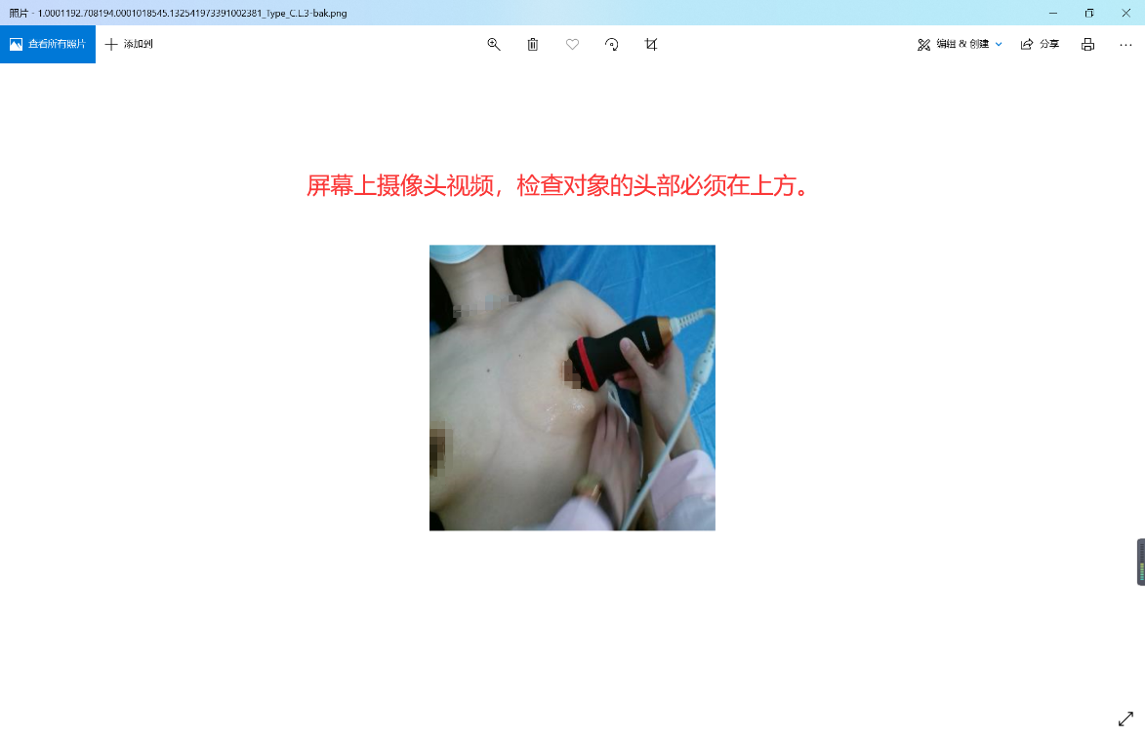
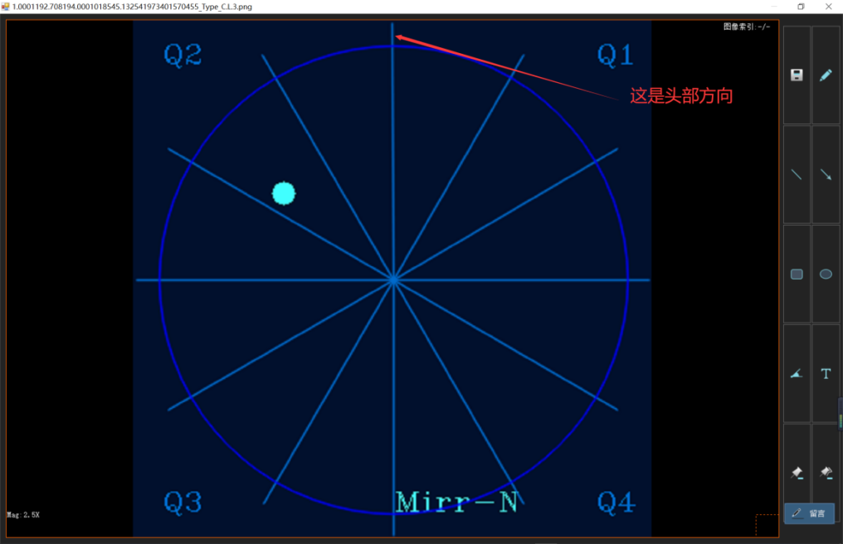

3. Why is it necessary for operators to perform the scan at least twice?
Since the operators are nurses or other non-ultrasound professionals, there is a risk of inconsistent scanning techniques. Additionally, during large-scale screening, operators may experience fatigue, inattention, or rushed execution, especially in later stages. To prevent incomplete scans or errors, each screening requires at least two full scans. This ensures that Dr. J’s backend AI system receives sufficient multi-angle imaging for accurate comparison and analysis.

4. Can Dr. J operate offline?
No, Dr. J requires an internet connection to function. The neural network system is deployed in the cloud, and all screening data is stored online. This allows:
Medical experts to analyze and diagnose screening results remotely via the internet.
Patients to have their medical data accessible for referral and follow-up treatment at higher-level hospitals.
Cloud deployment also supports the hierarchical medical service network, where AI empowers primary healthcare workers, alleviating the workload of senior medical specialists and ensuring an efficient tiered diagnosis and treatment system.

5. What are the network requirements for Dr. J?
Dr. J has low network requirements and can operate using a standard mobile network. Considering limited internet access in remote areas, the system has been optimized with specialized transmission algorithms to ensure reliable and timely data processing.

6. How long does a Dr. J screening take?
Excluding time for clothing adjustments, a single screening takes only about 3 minutes. However, patient information entry should also be factored in.
If patient data is collected in advance, the system allows batch import of screening participants using an Excel template, significantly reducing data entry time and minimizing human errors.

7. How does Dr. J ensure quality control (prevent missed scans and locate lesions)?
The Dr. J team has developed a patented technology that leverages computer vision tracking to monitor the probe’s scanning trajectory in real time. If an area is missed during the scan, the system automatically alerts the operator to rescan, preventing incomplete imaging.
Additionally, when the AI detects a lesion, the system automatically captures an image of the probe’s position and marks the lesion’s location on the clock diagram. This enables precise lesion localization and facilitates review by senior physicians. This breakthrough innovation is globally unique in the field.

8. Does poor ultrasound image quality increase the risk of misdiagnosis?
Yes, ultrasound image clarity can impact AI-based diagnosis.
Dr. J currently uses a standardized ultrasound probe with a central frequency of 7.5 MHz (range: 5.0–10.0 MHz). While its resolution may not match that of top-tier international ultrasound brands, it is designed specifically for AI analysis, rather than human visual interpretation.
Dr. J’s AI model has been extensively trained on this type of imaging, ensuring it can accurately analyze lesions despite the image resolution.
Additionally, we plan to upgrade the ultrasound probe’s specifications over time to enhance image clarity. This will not only improve AI analysis but also provide a better reading experience for human doctors.

9. How long does it take to receive screening results?
After screening, the AI system performs a secondary computation and analysis once all data has been uploaded to the cloud.
Since the daily screening volume varies, we have standardized the processing time to three working days for the final results.
Note: The initial screening result displayed on-site is only a preliminary AI assessment and should not be used as the final screening report for the participant.

10. Who is recommended to undergo screening with Dr. J?
Dr. J is suitable for all adult women.
Breast cancer is most common in women aged 40 to 50, but the age of onset varies by country and has shown a trend toward younger patients. We recommend that women start annual breast cancer screenings from the age of 30.

11. Can women undergo screening during menstruation, pregnancy preparation, pregnancy, breastfeeding, after breast augmentation, or after mastectomy?
Yes, screening can be performed in all these cases.

12. If the probe is scanned vertically and the operator's hand blocks the camera, preventing visibility of the scan point, will it affect the results?
During product development, we considered the possibility of momentary camera obstruction, and our AI algorithm compensates for such situations.
However, during normal operation, camera obstruction should be minimized. A brief blockage will not significantly impact the overall AI analysis.

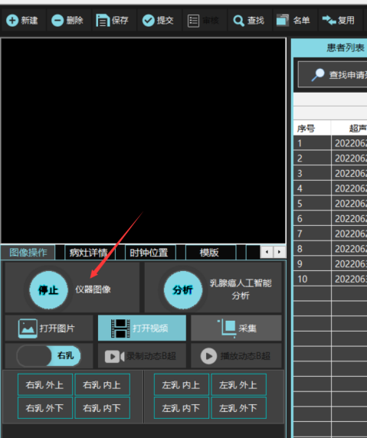
13. Why does the probe heat up during operation?
Dr. J's ultrasound probe handles part of the image processing calculations, so it may be slightly warmer than conventional ultrasound probes.
This heat generation is normal and does not affect probe performance. The maximum probe temperature is stabilized at around 40°C.
However, if the probe is not in use for an extended period, you should click “Stop Acquiring Instrument Images” to freeze the probe. This helps protect the probe and extend its lifespan.

14. Why do the thumbnail image in the tracking display and the large image on the right look different?
The thumbnail on the left is only a reference illustration. The large image on the right is the accurate one.

15. Why is the ultrasound image collected by the probe not clear?
The ultrasound images captured by the probe are not designed for human eyes but for AI analysis.
Even if the image appears unclear to the human eye, the AI algorithm analyzes every pixel and can still process the data effectively.
We are also planning to launch an upgraded probe in the future to enhance image clarity for both AI processing and human review.

16. Does the probe distinguish between left and right?
Yes, the probe is designed to distinguish left from right.
The protruding side of the probe corresponds to the green dot on the ultrasound interface—this represents the left side. The opposite side represents the right.
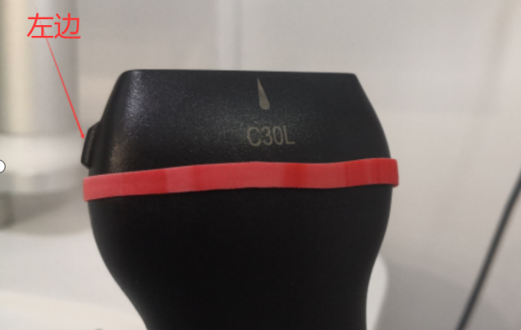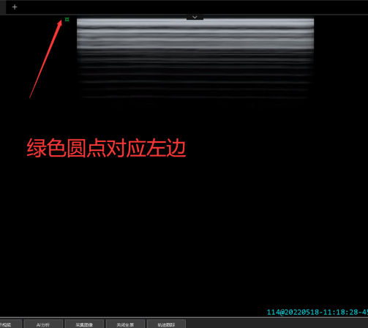

17. If the Dr. J system generates two images that appear to show the same nodule, should I classify it as one lesion or two?
The same lesion may be captured in multiple images. Dr. J will select the most severe image for BI-RADS classification.
If there are multiple lesions, the system will detect and mark them separately on the same ultrasound image.

18. I have completed the screening, but why can’t I see the result image on the right side of the screen?
Due to network speed differences, the client-side operation may be faster than the process of uploading, saving, and analyzing the data in the cloud.
Please wait a moment until all data is uploaded. Once the status at the bottom of the screen shows "All Uploaded," the system can retrieve the results from the cloud for viewing.

19. Why is the AI-marked lesion area larger than the manually marked area by an ultrasound doctor?
Dr. J is designed for early screening, and the AI intentionally marks a slightly larger area to capture the full lesion boundary.
This allows doctors to review and adjust the parameters if needed. Physicians can manually reduce the selection area for further analysis.

20. The lesion position marked on the clock diagram is similar, but the system generates multiple images. What do these different images represent? Are they different cross-sections of the same lesion?
During screening, Dr. J’s AI continuously analyzes and records lesion images from different cross-sections and angles to provide a more comprehensive assessment.
Additionally, doctors can review the ultrasound video recorded before and after lesion detection to assist in diagnosis.
When generating the early screening report, Dr. J selects the most representative image based on the severity of the lesion.

21. How should false-positive images caused by improper operation be handled?
False positives often result from insufficient use of coupling gel or inadequate pressure during scanning, creating gaps between the probe and the skin.
To prevent this, operators should undergo repeated training to standardize their technique.
After screening, all data is uploaded to the cloud, where AI performs secondary validation and filters out false positives caused by improper operation, reducing misdiagnoses.

22. Can Dr. J detect lesions smaller than 3mm?
Yes, Dr. J can detect lesions smaller than 3mm.
However, many doctors do not consider microcalcifications or tiny nodules during manual review. As a result, we have set a default threshold to capture lesions of 3mm or larger in the system.

23. Why does the message "Device is in use, please confirm" appear when opening the camera, and how can I resolve it?
If the camera is already on, you can use it directly.
If there is no real-time image and the system shows a "device in use" message when reopening the camera, restart the workstation to release the camera.
When registering a new patient, there is no need to close and reopen the camera—just click "Reset Parameters".

24. Will a red network warning affect normal usage?
A short-term red network warning is not an issue.
However, a persistent red warning indicates poor network signal, which can impact device performance.

25. Why can't I find previous patient information in the patient list?
The system only displays screening records from the past 3 days.
For records older than 3 days, use the "Search" bar and enter a keyword (such as the patient's name) to retrieve the information.

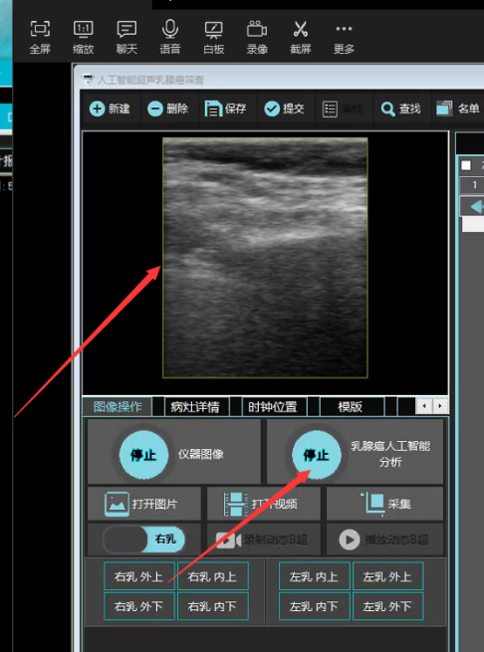
26. Why is there no image for the screened individual?
First, check if the "Analyze" button was clicked.
If the system is in analysis mode, the button will show "Stop", and a yellow border will appear around the image.
If the button still says "Analyze" and no yellow border is visible, the system is not in analysis mode. In this case, stop the screening process and restart the full procedure.
If analysis is active, and the left and right breasts were scanned at least twice, but no images appear, the AI has likely determined that the patient is healthy.

27. Can Dr. J detect nodules smaller than 3mm?
In breast cancer screening, human doctors often ignore very small nodules, considering them clinically insignificant.
To align with this practice, Dr. J also ignores or hides nodules under 3mm, categorizing individuals with such nodules as healthy.

28. Can Dr. J scan underarm lumps?
In standard breast cancer screening, scanning the underarm provides a more comprehensive assessment.
However, Dr. J currently does not support underarm scanning.

Why can’t I see the “Trajectory Tracking Map”?
By default, the Trajectory Tracking Map is hidden.
To display it, go to the “Lesion Details” menu and check the “Show Trajectory Map” option.
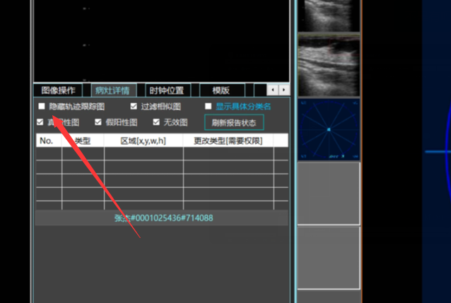
This feature allows users to toggle the visibility of the trajectory map and organizes all imaging data into structured groups for better review.

Why does the lesion type only show "abnormality" instead of specific classifications?
In the "Lesion Details" interface, click "Show Specific Classification Names" to display the specific lesion classifications.
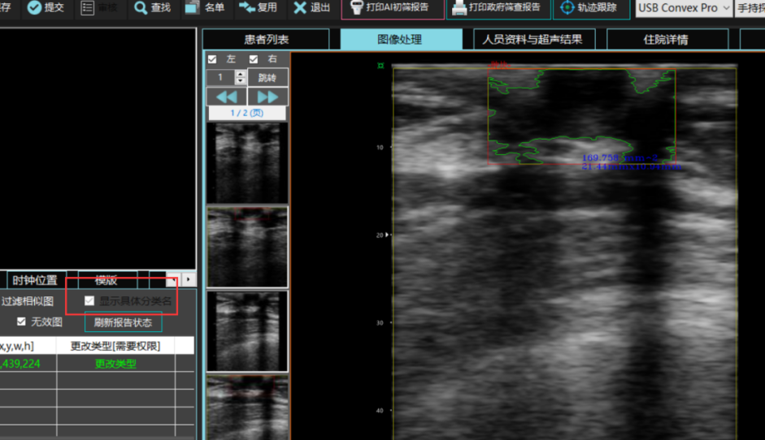

Why is there no response when clicking "New" to add the next subject after completing a scan?
You must first click "Stop" to terminate the current analysis before creating a new subject. If "Stop" is not pressed, the system remains in analysis mode, and all function keys in the upper interface are disabled during this process.

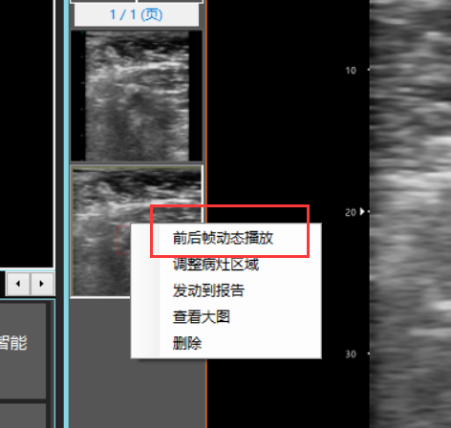
What should I do if the captured lesion images are blurry?
Click the "Play Adjacent Frames" button to dynamically review sequential frames and observe the lesion from multiple angles for diagnostic support.
The ultrasound probe included with Dr. J is optimized to provide imaging data for AI algorithm analysis, not human visual interpretation. While blurriness may be noticeable to the human eye, the AI algorithm analyzes individual pixel data to ensure accurate diagnosis.
We will launch an upgraded probe in future updates to improve ultrasound image clarity for both AI and human review.

How should the ultrasound probe be maintained and cleaned?
Cleaning and Disinfection of the Probe
After each use, the probe must be cleaned, disinfected, and sterilized. Follow these guidelines to avoid damage:
a) Temperature limits: 0°C to 65°C.
b) Do not use organic solvents for wiping or disinfection.
c) Avoid steam autoclaving or ethylene oxide exposure.

Cleaning Procedure
a) After use, wipe the probe surface with a soft cloth dampened with water.
b) For stubborn dirt, use a neutral soap solution and a soft cloth or cotton ball, then rinse with water.
c) Dry the probe thoroughly with a clean, dry cloth.

Disinfection and Sterilization
a) Use 2% glutaraldehyde solution (pH 7.5–8.5) or 0.01% benzalkonium bromide solution (pH 7.5–8.5) for disinfection.
b) After disinfection, rinse the probe with sterile water and dry with a soft cloth.
c) The probe is not pre-sterilized; follow local safety protocols for disinfection.

Important Notes:
- Do not use organic solvents to clean the probe.
- Do not use expired disposable sterile sheaths.
- Dispose of cleaning waste securely to prevent environmental contamination.

Additional Guidelines
1. During scanning, operators should monitor the system interface and rescan areas where lesions are detected to capture multiple angles, aiding physician review.
Example: If a lesion is detected, pause the probe at that location for additional scans to provide comprehensive data.

2. When capturing quadrant images, ensure the probe is firmly pressed against the breast.
Images not meeting standards (as shown below) must be retaken.

